Year 11 General Biology
Task 5 – Cells Processes


Part A: Multiple-choice (11 marks)

Section A consists of 11 questions, each worth one mark. Each question has only one correct answer.

- The cell membrane of living cells
- Protects, supports and gives shape to the cell
- Controls the flow of substances in and out of the cell
- Is the part of the cell where photosynthesis
- Supplies energy to all the other parts of the cell

- Which organelle is the site of cellular respiration?
- chloroplast
- golgi apparatus
- endoplasmic reticulum
- mitochondrion

- Where does gas exchange occur in animals?
- Left Broncus
- Trachea
- Alveoli
- Terminal Bronchiole

- Photosynthesis in green plants only occurs when the plant is in the light. When does respiration occur in green plants?
- Only in the dark
- At all times
- Only in the light
- When sufficient ATP is present

- Which of the following is not directly needed by plants for photosynthesis?
- carbon dioxide
- bacteria
- light
- water

- The green pigment in a plant is called ___________.
- Chlorophyll
- Chlorine
- Mitochondria
- Mesophyll

- What is the term that is best described as the diffusion of water through a selectively permeable membrane?
- Diffusion
- Osmosis
- Water transfer
- All of the above

- All of the following are parts of the equation for cellular respiration, EXCEPT
- glucose
- oxygen
- carbon dioxide
- ADP

Use the following diagram to answer questions 16 and 17.
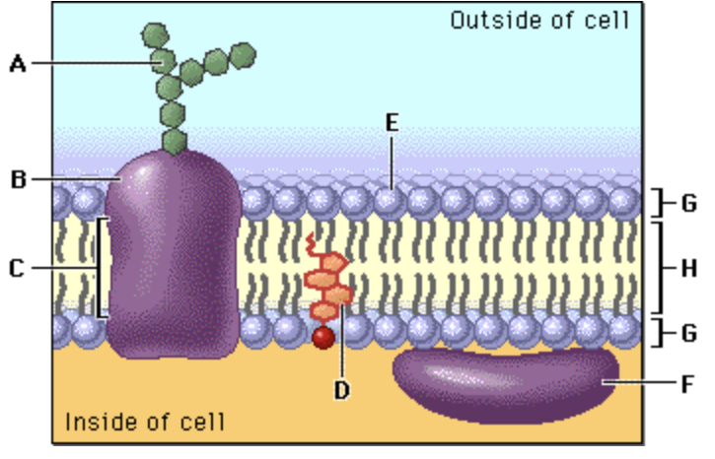

- In the diagram, structure E corresponds to:
- Protein
- Carbohydrate
- Lipid layer
- A hydrophilic structure

- In the diagram above, structure H corresponds to:
- A hydrophobic structure
- Cholesterol
- An integral protein
- A hydrophilic structure

- What is osmosis?
- Diffusion of water through a semi-permeable membrane
- When you take water out of a cell
- When you put water into the cell
- When you put water out the cell

END OF MULTIPLE CHOICE QUESTIONS

Part B: Short answer (21 marks)

Answer all questions in the spaces provided.

- Define the following

Active transport

Transport that requires energy to move across a membrane (1 mark)
Passive transport

Does not require to move across a membrane (1 mark)

- Describe how surface area to volume ratio can affect the rate of diffusion of different types of substances across membranes. (2 marks)

Higher surface area to volume increases rate of diffusion (1 mark) a greater percentage of the overall volume is exposed to the diffusing substances (1 mark)

- Describe what has happened in the diagram below. (2 marks)
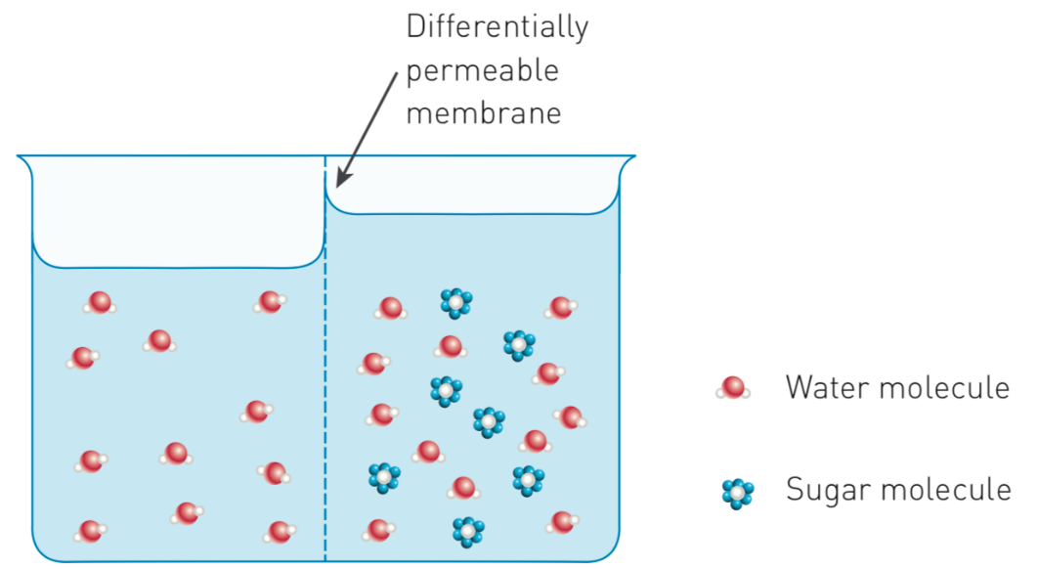

The sugar has caused a difference in osmotic pressure (1 mark)
The water has shifted across to the side with lower osmotic pressure (1 mark)

- The transportation of sugars and water within plants is essential for life. On the diagram of a tree below, use a blue pen to draw arrows to show the direction of water movement. Use a red pen to draw arrows to show the direction of sugar movement.
(2 marks)

- Photosynthesis is a series of chemical reactions catalyzed by enzymes that occurs in the chloroplasts of plant cells.

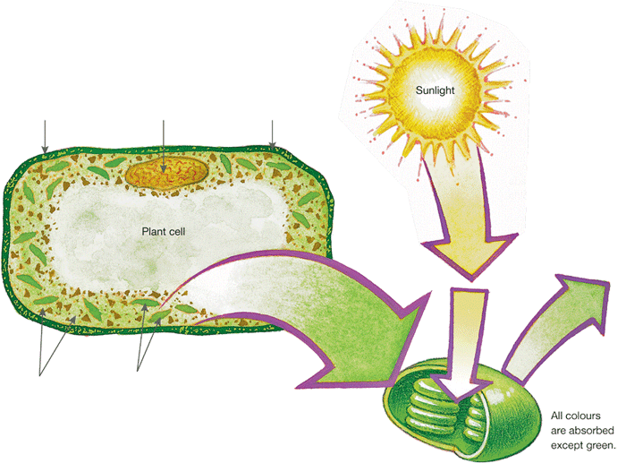
Identify the appropriate terms to label the figure below. (3 marks)

Cell Membrane

ATP/sugar/
glucose
Cell wall
Nucleus
Cytoplasm
Chloroplast

- Write a word equation for photosynthesis. (2 marks)
Sunlight + carbon dioxide + water = oxygen + ATP + Water (-1 mark for each error)

- Write a word equation for respiration. (2 marks)
Oxygen + glucose = carbon dioxide + water (-1 mark for each error)

- Write a chemical equation for respiration. (2 marks)
C₆H₁₂O₆ + 6O₂ → 6CO₂ + 6H₂O (-1 mark for each error)

- A man was training for a 15 km fun run. He noticed that after 10 km his legs started to ache. Explain what is happening inside his muscle cells. (2 marks)
Anaerobic energy system has begun to run out (1 mark) has started to produce waste products (lactic acid) (1 mark)

- What is the main difference between AEROBIC and ANAEROBIC respiration?
(2 marks)
Anaerobic respiration does not require oxygen, creates lactic acid waste (1 mark)
Aerobic respiration requires oxygen, creates CO₂ waste ( 1mark)
END OF SHORT ANSWER QUESTIONS

Section C: Short Answer (8 marks)

Section C consists of 2 questions.
Write your answers in the spaces provided. You are advised to spend 10 minutes on this section.

1. A student set up the following experiment.

The experiment was left out on an open oval from 7:00 am to 5:00 pm on a sunny day. Explain the difference in the concentration of oxygen and carbon dioxide in the jars. (4 marks)

Oxygen concentration
Oxygen in glass jar will be higher due to increases photosynthesis
Oxygen in painted/dark jar will be lower to less photosynthesis
Carbon dioxide concentration
Carbon dioxide in glass jar will be lower as more photosynthesis has occurred
Carbon dioxide in painted/dark jar will be higher as less photosynthesis has occurred

2. The cells below are erythrocytes (red blood corpuscles). Varying amounts of sucrose were added to the extracellular environments A, B and C. Each of the three pictures depicts them in a different extracellular environment.
Describe fully the solutions and the processes that occur in the stages shown at A and C.
(4 marks )
Stage A
The solution is hypertonic to the cells (1 mark) causing a movement of fluid out of the cells into the solution (1 mark)
Stage C
The solution is hypotonic to the cells (1 mark) causing a movement of fluid into the cells causing swelling/damage (1 mark)
END OF TEST

